**Advanced C programming**

**CSE2010**

**LAB2 – Practice Assignments.**

2021-08-12

Bimal Parajuli (20BDS0405).

1. Write a program to print the output of the series, 1 + x + 2x + 3x... and 1 + x/2 + 2x/3 + 3x/4... (Use double for output) till n numbers, where n is coefficient of x.
2. Write a program to get four integer variables as input and do the check whether each of them is divisible by 2 and 3 or it is divisible by 5. If it is true and if more than one value is satisfying the condition then select the largest of the numbers which satisfy the condition and pass that particular value by reference to a function refer, multiply it by 10 and print the variable value in the main.
3. Write a program to print the nearest integer value of corresponding float value given by the user, without using any library function.
4. Write a program to convert and display a decimal number in number with base 26, with its digit being represented as alphabets from a - z. Maximum size of input is 26*26.

(Omitted Question… To be done later).

1. Write a program using function to indicate whether a given number is divisible by 5 or 6, if divisible by 5 multiply it to 6 or vice versa and return the value, indicate the divisibility also (which has to be calculated in the function).

Qn1:

Codes:

#include<stdio.h>

int main()

{

    int n, x;

    double db1=1, db2=1;

    printf("Enter the value of 2 positive integers n  x  :");

    scanf("%d %d", &n, &x);

    printf("\n\nThe series 1 + %d + 2*%d + 3*%d... results ", x, x, x);

    for (int i=1; i<n; i++)

    {

        db1 += (i*x)/1.0;

    }

    printf("%.1lf", db1);

    printf("\n\nThe series 1 + %d/2 + 2%d/3 + 3%d/4... results ", x, x, x);

    for(int i=0; i<n; i++)

    {

        db2 += ((double)(i*x))/(i+1);

    }

    printf("%.4lf\n\n", db2);

    return 0;

}

Output Screen (Multiple Test cases):

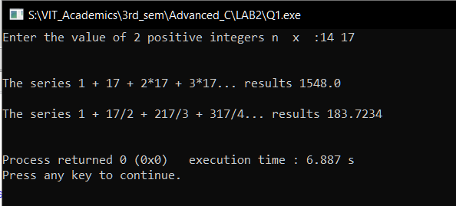

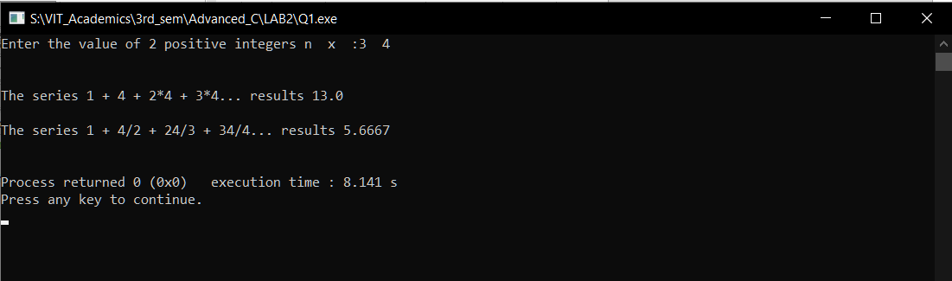

Qn2:

Codes:

#include <stdio.h>

void mul10(int *max)

{

    *max = *max * 10;

}

int divisible(int);

int main()

{

    int a, b, c, d, max = 0;

    printf("Enter four numbers: a b c d -");

    scanf("%d %d %d %d", &a, &b, &c, &d);

    max = 0;

    if (divisible(a))

    {

        if (a > max)

        {

            max = a;

        }

    }

    if (divisible(b))

    {

        if (b > max)

        {

            max = b;

        }

    }

    if (divisible(c))

    {

        if (c > max)

        {

            max = c;

        }

    }

    if (divisible(d))

    {

        if (d > max)

        {

            max = d;

        }

    }

    if (max == 0)

    {

        printf("No any number satisfied divisibility.");

    }

    else

    {

        mul10(&max);

        printf("The required output is: %d", max);

    }

    return 0;

}

int divisible(int x)

{

    if ((x % 2 == 0 && x % 3 == 0) || x % 5 == 0)

    {

        return 1;

    }

    return 0;

}

Output Screen(Multiple Test Cases):

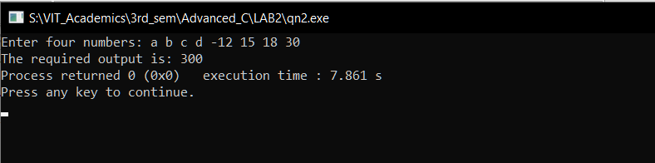

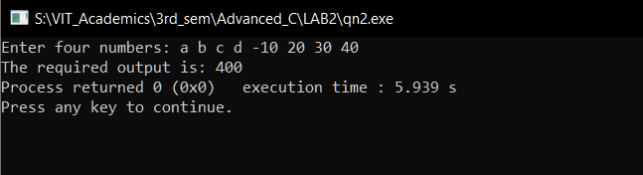

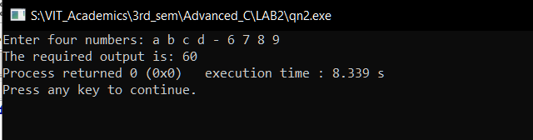

Qn3:

Codes:

#include <stdio.h>

int main()

{

    float x;

    scanf("%f", &x);

    x = x + 0.5;

    printf("%d", (int)x);

    return 0;

}

Output Screen (Diverse test Cases):

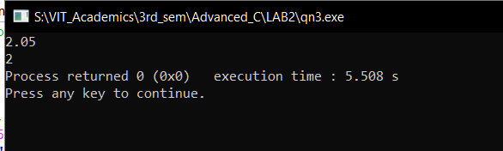

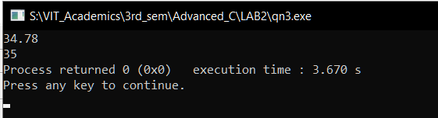

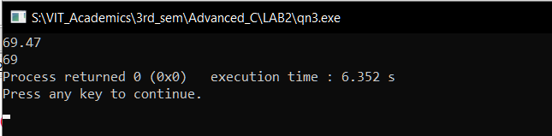

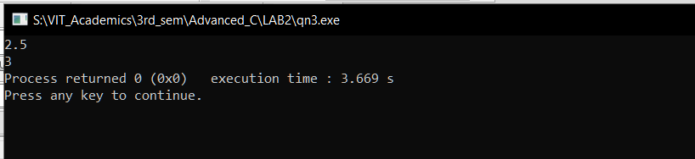

Qn5:

Codes:

#include <stdio.h>

int func(int a, int *b)

{

    if (a % 5 == 0 && a % 6 == 0)

    {

        return 1;

    }

    else if (a % 5 == 0)

    {

        *b = 5;

        return a * 6;

    }

    else if (a % 6 == 0)

    {

        *b = 6;

        return a * 5;

    }

    return 0;

}

int main()

{

    int x, val, divisiblity = NULL;

    printf("Enter a number: ");

    scanf("%d", &x);

    val = func(x, &divisiblity);

    if (val == 0)

    {

        printf("Not divisible by 5 or 6.");

    }

    else if (val == 1)

    {

        printf("Divisible by both 5 and 6.");

    }

    else

    {

        printf("Result after multiplication is: %d and the divisibility is: %d", val, divisiblity);

    }

    return 0;

}

Output Screen (Diverse Test cases).

